Building a Digital Watershed
Suwannee River Watershed HO Subcommittee 6
March 21, 2005

ArcHydro

Find the HIS Symposium in Austin summary at http://suwanneeho.ifas.ufl.edu/documents.htm

ArcHydro is being implemented as the data model for hydrological data by the HIS team at the University of Texas and will be used to structure our data collection and synthesis (see http://www.crwr.utexas.edu/giswr/hydro/ArcHOSS/index.cfm). We would like to build a base ArcHydro system within the next 2-3 months. We can use your input. Have you used ArcHydro? Can you help us access data needed?

ArcHydro is a data structure and toolset built for the ArcGIS environment to manage hydrologic spatial and measurement (time series) data.

Archydro spatial features describe:
- Drainage areas
- Hydrography
  - Points (dams, bridges, wiers, structures, monitoring points)
  - Lines (rivers, streams, canals etc.)
  - Areas (floodplains, estuaries, wide rivers, wetlands, lakes)
- HydroNetwork
  - HydroEdges (same as hydrography lines) – direction of flow is stored
    - Flowlines
    - Interfaces (mostly shorelines at ocean)
  - HydroJunctions (Sink (if it is an outlet), confluences)

Hydroedges, HydroJunctions, drainage areas, and hydrography can all be related to each other with common attribute fields (HydroID, FunctionID) so you know where a drainage area drains to, which drainage area a stream drains etc.

Stream channel cross-sections can be stored in Archydro.

Other spatial layers can be added, for example:
- Nexrad rainfall raster
- Land Use raster
- Soils raster
- Digital Elevation Model (DeM)
- Groundwater flow model grids

Time series data (flow, water quality) can be associated with hydrography points which will be related to other features.

Some tools available in ArcHydro:
- upstream tracing
- downstream tracing
- accumulation - estimate flow at a point, or precipitation in a drainage area etc
- consolidation – do stats of other layers rel. to a hydrofeature (max, min, mode, median, sum, mean, stddev)
- Delineation of floodplains using DEMs
- Delineation of drainage areas using DEMs
- Creating river cross sections using Digital Terrain Models
- More….

Data to be used the ArcHydro Effort – Suwannee River Watershed
- National Hydrography Dataset (see http://nhd.usgs.gov/)
First let’s define NHD terms:
    - USA has 20 2-digit water resource regions
    - 4-digit subregions (Suwannee River watershed = 0311)
    - 6-digit basins
    - 8-digit subbasins (Figure 1)
    - 10-digit watersheds
    - 12-digit subwatersheds (Figure 1)

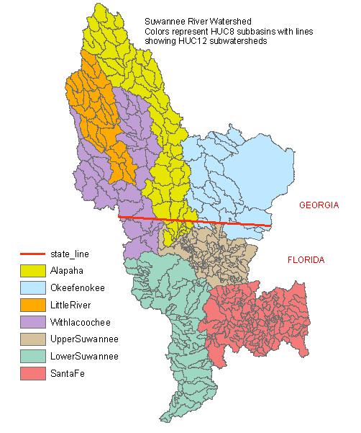
Figure 1 – Subbasins and subwatersheds (note: Okeefenokee and Upper Suwannee are parts of the same HUC8 subbasin “Upper Suwannee”)

NHD has
a. 1:100,000 lines for all 7 HUC8 basins
  - 1:24,000 lines for Little and Santa Fe watersheds
  - Waterbodies
  - Points:
    - Springs (imcomplete?)
    - Gaging stations, Monitoring stations, wells (incomplete)
    - Hydrojunctions (see Figure 2)

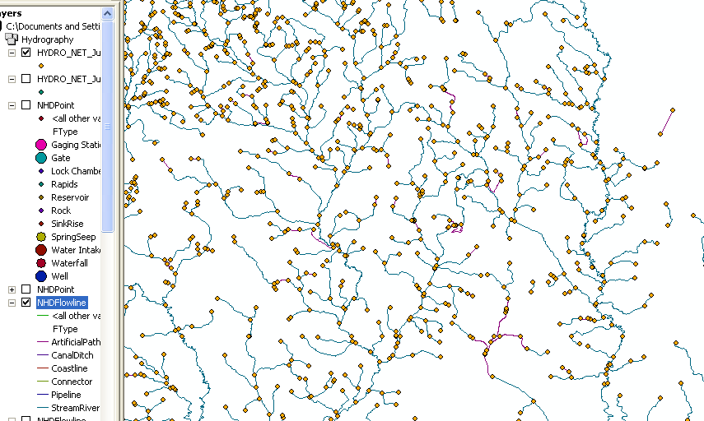
Figure 2. HydroNetJunctions mark endpoings of stream reaches.

- Land cover (figure 3) -- Satellite-based (1992) (see http://www.epa.gov/mrlc/nlcd.html) (2001 available for purchase unless someone knows someone who has it.)
- Land Use -- Aerial photo-based (1995)
- Soils – SSURGO & STATSGO
- Digital Elevation Model: Elevation, slope, aspect, topographic domains. (Figure 4)
- Geology (stratigraphy, aq. confinement)
- Nexrad (see http://www.roc.noaa.gov/ and http://sysu1.wsicorp.com/unidata/intro.html ) See live weather at http://www.rap.ucar.edu/weather/radar/

For the Little and Santa Fe watersheds, we will gather time series data. This will reduce the quantity of time and data required to produce a complete dataset within a reasonable period of time.
- Groundwater levels
  - USGS (GA and FL) (in NWIS)
  - SRWMD (in Oracle db) 70 continuous recorders, 110 manuals
  - GA DNR

- Surface Water Levels
  - USGS (NWIS)
  - SRWMD
  - GA DNR

- Water Quality (may be reserved for a future effort)
  - EPA Storet (http://www.epa.gov/storet/)
  - USGS (NWIS)
  - NAWQA
  - GA DNR

- Climate Data (daily)
  - Precipitation
  - Air Temp
  - Soil Moisture (may be reserved for future effort)
  - Automated Weather Data – GA (http://www.georgiaweather.net/)
  - FAWN http://fawn.ifas.ufl.edu/
  - NCDC
  - More…

We will start with NWIS data for time series data and go from there. We have permission to access NWIS database in Tallahasee directly.

We would appreciate any help from experienced ArcHydro users!

We aim to have a digital watershed with base layers for the whole watershed and time series data for the Little and Santa Fe watersheds.

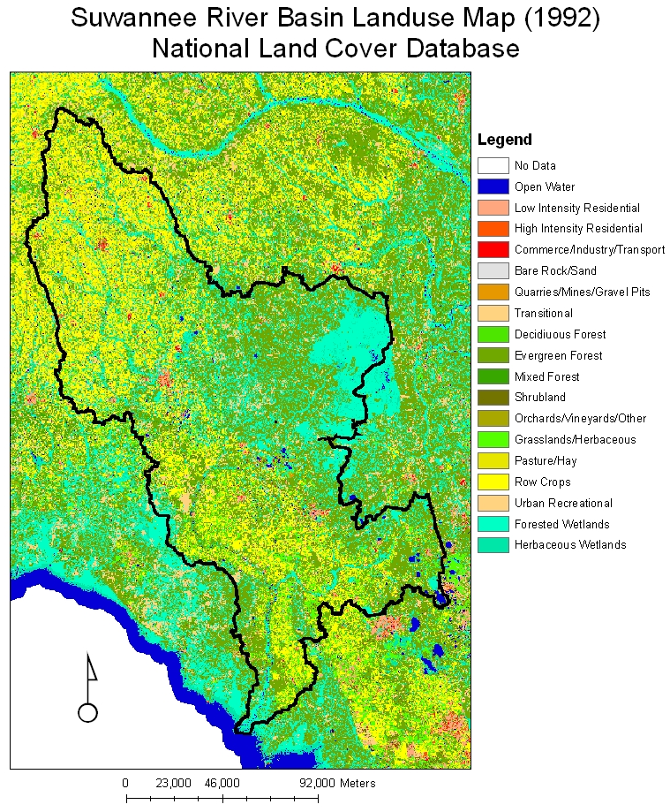
Figure 3. Land cover based on Landsat imagery.

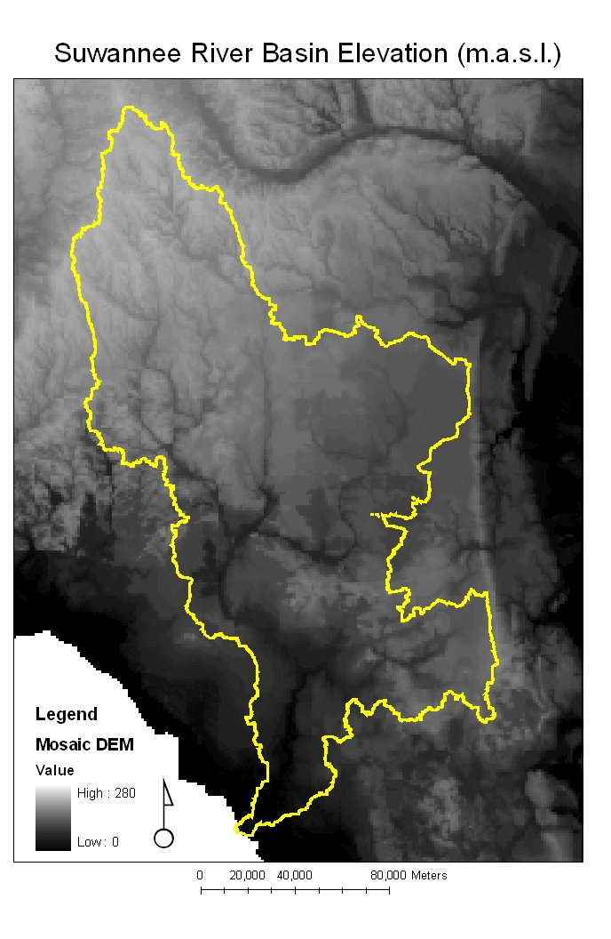
Figure 4. Digital Elevation Model.

