Appendix - Time Series Datasets

Stream Levels and Discharges:
Staff gages and wire weight recorders are measured hourly or daily in the Santa Fe watershed by USGS and the SRWMD. Six of the stations are available from the USGS National Water Information System (NWIS) online database. Data for remaining stations will be provided quarterly by the SRWMD.

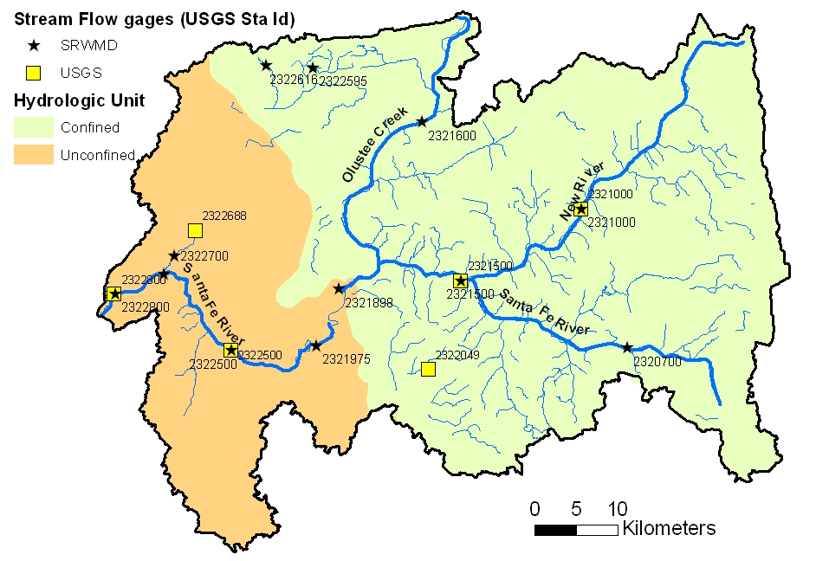
Figure 1. Active stream gages in the Santa Fe watershed, Florida.

Table 1. Rivers/creeks water levels and discharge active gages of interest in Santa Fe watershed.
USGS # | Name | Agency | Disch. | Levels | Dates
02320700 | Santa Fe River at Graham | SRWMD | Daily | Hourly | 1957 – present
02321000 | New River near Lake Butler | USGS/SRWMD | Daily | Hourly | 1950- present
02321500 | Santa Fe River at Worthington Springs | USGS/SRWMD | Daily | Hourly | 1931 – present
02321600 | Olustee Creek near Lulu | SRWMD | Daily | Hourly | 11/2002 – present
02321898 | Santa Fe River at O’Leno State Park | SRWMD | Daily | Daily | 10/1998 – present
02321975 | Santa Fe River at High Springs at 441 | SRWMD | Daily | Hourly | 10/1993 – present
02322049 | Bad Dog Branch near Alachua | USGS | Daily | Hourly | 10/1998 - present
02322500 | Santa Fe River near Fort White | USGS/SRWMD | Daily | Hourly | 1927 – present
2322595 | Price Creek near Lake City | SRWMD | Daily | Hourly | 10/1998 – present
2322616 | Cannon Creek near Lake City | SRWMD | Daily | Hourly | 10/1992 - present
02322688 | Blue Hole Spring near Hildreth | USGS | Daily | Hourly | 02/2002 - present
2322700 | Itchetucknee River near Hildreth | SRWMD | Daily | Hourly | 11/1998 - present
02322800 | Santa Fe River near Hildreth | USGS/SRWMD | Daily | Hourly | 11/2000 – present

Surfacewater Quality:
The US EPA maintains a data repository for water quality data collected by the SRWMD and the Florida Department of Environmental Protection. This data is available online from their storage and retrieval system known as STORET. Data is loaded into STORET quarterly.

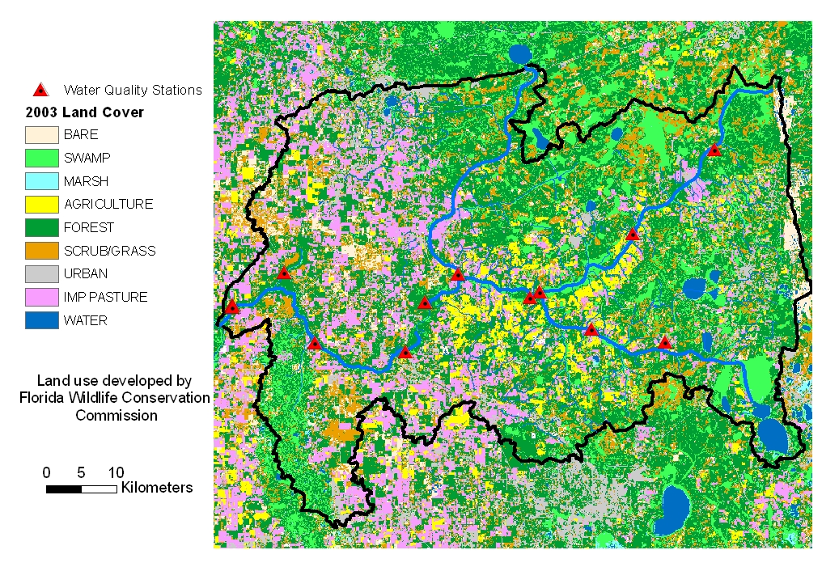
Figure 2. Surfacewater quality stations with recent nitrogen data.

Table 2. Stream water quality monitoring stations in Santa Fe watershed.
STORET# | Stream | STORET Nitrogen Data  (~ monthly)
SMR010C1 | Sampson River | 02/1989 – 02/2005
OLS010C1 | Olustee Creek | 02/1989 – 02/2005
SFR020C1 | Santa Fe River | 02/1989 – 02/2005
SFR030C1 | Santa Fe River | 02/1989 – 02/2005
SFR040C1 | Santa Fe River | 02/1989 – 02/2005
SFR050C1 | Santa Fe River | 02/1989 – 02/2005
SFR060C1 | Santa Fe River | 02/1989 – 02/2005
SFR070C1 | Santa Fe River | 02/1989 – 02/2005
ICH010C1 | Itchetucknee River | 02/1989 – 02/2005
NEW010C1 | New River | 02/1989 – 08/1998
NEW009C1 | New River | 02/1989 – 02/2005
NEW007C1 | New River | 02/1989 – 02/2005

Groundwater Levels:
The SRWMD maintains a groundwater level database with wells that are measured monthly, and others that are measured continuous (daily).

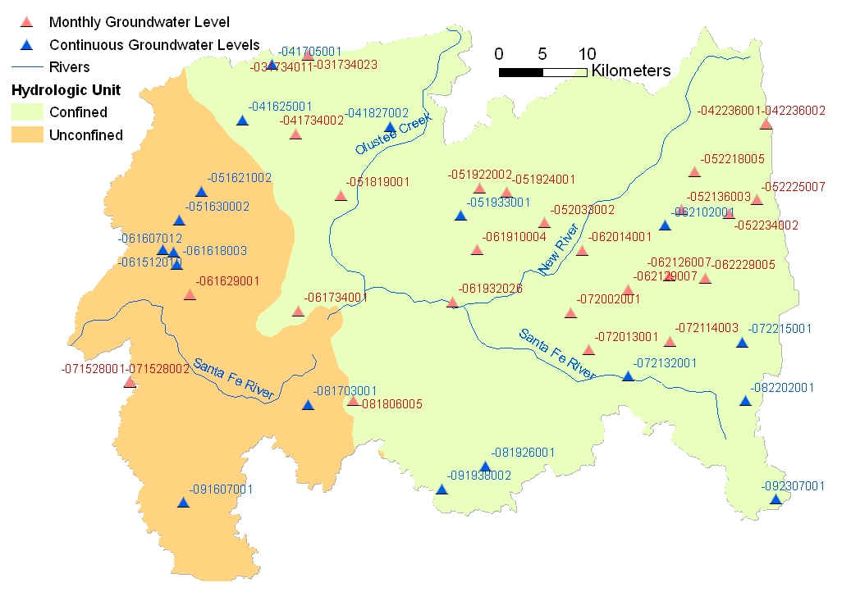
Figure 3. Monthly and continuous groundwater level wells.

Table 3. Continuous (daily) groundwater levels recorded in Santa Fe watershed.
SITE ID | DATFMEAS | DATLMEAS | MAXWL | MINWL | DATMIN | DATMAX | FLUC | NUMREC
-041625001 | 11/1/76 | 7/25/05 | 48.89 | 30.05 | 12/21/02 | 5/4/84 | 18.84 | 8567
-041705001 | 6/4/48 | 7/12/05 | 64.11 | 41.24 | 11/8/02 | 6/4/48 | 22.87 | 8165
-041827002 | 8/19/88 | 7/20/05 | 58.84 | 45.08 | 8/17/02 | 4/1/98 | 13.76 | 5948
-051621002 | 9/27/01 | 7/22/05 | 39.08 | 26.14 | 9/4/02 | 7/22/05 | 12.94 | 634
-051630002 | 4/2/02 | 7/19/05 | 41.05 | 24.79 | 11/18/02 | 1/20/04 | 16.26 | 998
-051933001 | 3/1/65 | 7/6/05 | 64.52 | 48.77 | 7/21/02 | 3/1/65 | 15.75 | 7695
-061512010 | 3/25/02 | 7/19/05 | 29.08 | 21.74 | 7/25/02 | 4/22/05 | 7.34 | 1083
-061607012 | 3/25/02 | 7/19/05 | 29.05 | 22.88 | 9/3/02 | 4/20/05 | 6.17 | 128
-061618003 | 3/28/02 | 7/19/05 | 29.36 | 22.12 | 6/28/02 | 4/20/05 | 7.24 | 897
-062102001 | 11/2/60 | 7/14/05 | 68.18 | 52.46 | 6/20/02 | 11/2/60 | 15.72 | 8389
-072132001 | 11/1/76 | 6/21/05 | 68.96 | 56.26 | 6/17/02 | 4/24/84 | 12.7 | 3582
-072215001 | 11/1/76 | 6/21/05 | 88.53 | 76.4 | 6/20/02 | 5/4/84 | 12.13 | 7952
-081703001 | 9/17/64 | 6/17/05 | 43.61 | 30.33 | 7/19/02 | 9/17/64 | 13.28 | 7600
-081926001 | 2/14/78 | 6/17/05 | 47.46 | 36.7 | 10/10/02 | 6/23/84 | 10.76 | 8771
-082202001 | 2/11/88 | 8/2/05 | 83.72 | 70.88 | 6/20/02 | 4/4/98 | 12.84 | 6008
-091607001 | 11/1/76 | 5/25/05 | 76.73 | 39.51 | 7/28/02 | 10/5/04 | 37.22 | 8145
-091938002 | 8/13/80 | 7/21/05 | 74.78 | 43.57 | 12/7/81 | 9/4/85 | 31.21 | 7526
-092307001 | 11/1/76 | 6/21/05 | 89.36 | 77.13 | 6/18/02 | 3/21/98 | 12.23 | 8042

Table 4. Monthly groundwater levels recorded in Santa Fe watershed.
SITEID | DATFMEAS | DATLMEAS | MAXWL | MINWL | DATMIN | DATMAX | FLUC | NUMREC
-031734011 | 8/5/1992 | 7/26/2005 | 67.4 | 46.53 | 12/23/2002 | 3/20/1998 | 20.87 | 167
-031734023 | 6/6/1989 | 7/26/2005 | 194.94 | 189.07 | 12/18/1990 | 3/20/1998 | 5.87 | 191
-041734002 | 6/6/1989 | 7/25/2005 | 44.97 | 29.9 | 11/26/2002 | 6/2/2005 | 15.07 | 102
-042236001 | 7/16/1987 | 7/15/2005 | 62.83 | 50.16 | 6/24/2002 | 3/26/1998 | 12.67 | 504
-042236002 | 6/5/1989 | 6/21/2005 | 206.26 | 196.44 | 7/16/2001 | 9/14/2004 | 9.82 | 192
-051819001 | 11/1/1976 | 7/25/2005 | 48.32 | 37.26 | 8/21/2002 | 3/24/1998 | 11.06 | 272
-051922002 | 6/5/1989 | 7/19/2005 | 141.17 | 132.68 | 12/19/1990 | 1/30/1998 | 8.49 | 192
-051924001 | 2/22/1996 | 7/19/2005 | 133.79 | 123.28 | 6/19/2002 | 4/20/2005 | 10.51 | 112
-052033002 | 8/29/1905 | 7/19/2005 | 127.06 | 117.14 | 6/19/2002 | 2/27/1998 | 9.92 | 122
-052136003 | 12/28/1995 | 7/15/2005 | 135.12 | 126.3 | 1/16/2001 | 2/27/1998 | 8.82 | 116
-052218005 | 11/3/1995 | 7/15/2005 | 134.7 | 125.1 | 6/30/2000 | 2/27/1998 | 9.6 | 115
-052225007 | 12/28/1995 | 7/15/2005 | 160.7 | 152.46 | 5/24/2000 | 2/27/1998 | 8.24 | 112
-052234002 | 10/31/1995 | 6/21/2005 | 144.31 | 135.59 | 6/11/2001 | 2/27/1998 | 8.72 | 113
-061629001 | 12/23/1962 | 7/25/2005 | 32.99 | 18.62 | 6/17/2002 | 3/25/1998 | 14.37 | 274
-061734001 | 11/1/1976 | 7/25/2005 | 41.5 | 30.66 | 8/23/1993 | 2/26/1998 | 10.84 | 278
-061910004 | 2/22/1996 | 7/19/2005 | 109.53 | 98.36 | 6/19/2002 | 6/22/2005 | 11.17 | 115
-061932026 | 7/28/1998 | 7/19/2005 | 54.98 | 44.53 | 6/19/2002 | 5/11/2005 | 10.45 | 82
-062014001 | 2/22/1996 | 7/15/2005 | 130.12 | 119.46 | 10/16/2002 | 2/27/1998 | 10.66 | 117
-062126007 | 9/27/1995 | 3/10/2005 | 139.14 | 128.7 | 6/18/2001 | 3/19/2003 | 10.44 | 116
-062129007 | 9/6/1995 | 7/15/2005 | 138.76 | 127.9 | 6/18/2001 | 2/27/1998 | 10.86 | 125
-062229005 | 10/24/1995 | 7/15/2005 | 140.95 | 134.75 | 3/20/2001 | 2/27/1998 | 6.2 | 119
-071528001 | 8/14/1990 | 7/13/2005 | 71.65 | 63.89 | 5/15/2002 | 3/20/1998 | 7.76 | 167
-071528002 | 8/16/1990 | 7/26/2005 | 72.6 | 64.01 | 6/11/2002 | 3/20/1998 | 8.59 | 167
-072002001 | 2/12/1988 | 3/10/2005 | 65.5 | 52.5 | 6/17/2002 | 3/26/1998 | 13 | 2031
-072013001 | 6/5/1989 | 7/15/2005 | 141.11 | 133.34 | 10/6/1993 | 2/27/1998 | 7.77 | 190
-072114003 | 10/24/1995 | 7/15/2005 | 143.79 | 133.69 | 7/17/2002 | 2/27/1998 | 10.1 | 112
-081806005 | 10/22/2004 | 7/19/2005 | 37.59 | 34.74 | 3/15/2005 | 10/22/2004 | 2.85 | 128

Groundwater Quality:
The SRWMD has two groundwater quality networks that began in October 2000.
- The Trend Network is sampled quarterly and allows the assessment of changes in groundwater quality (the Floridan aquifer) over time.
- The Status Network wells are sampled once per year generating statistically valid snapshots of the overall annual groundwater quality.

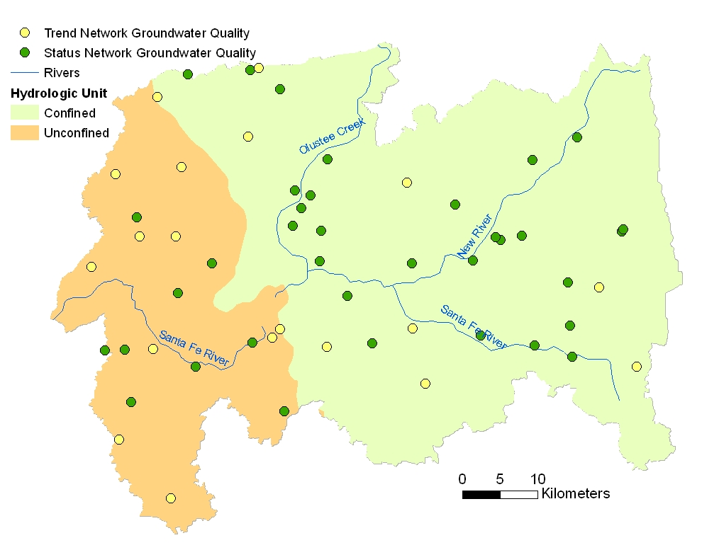
Figure 4. Groundwater quality monitoring wells in the Santa Fe Watershed, Florida.

Table 5. WARN Groundwater Quality Network Parameters.
Physical/Biological | Minor Ions
Turbidity | Iron
Total Dissolved Solids | Lead
Alkalinity as CaCO3 | Cadmium
Total organic carbon | Arsenic
Dissolved organic carbon | Nutrients
Major Ions | Nitrate plus nitrite
Potassium | Total Kjeldahl nitrogen
Sodium | Ammonia nitrogen
Magnesium | Total phosphorus
Calcium | Orthophosphate
Chloride
Fluoride
Sulfate

Rainfall Stations:
The SRWMD maintains an automated network of tipping bucket rain gages that are available real-time on an hourly basis. The SRWMD observer network is collected by the Department of Forestry (DOF), the National Oceanic and Atmospheric Administration (NOAA) and private citizens on a daily basis. Other rainfall data is collected by the Florida Automated Weather Network (FAWN) and an Ameriflux Tower, south of the watershed. The FDOT has 1 and a half years of climate including rainfall.
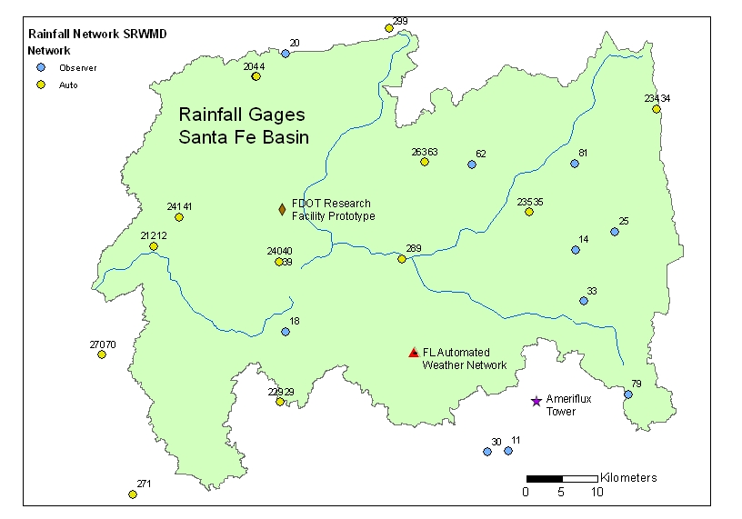
Figure 5. Rainfall network in the Santa Fe watershed, Florida.

Table 6. Rain gages of in the Santa Fe watershed.
ID | Name | Agency | Type | Yrs of Record | Frequency
204 | Alligator Lake | SRWMD | Auto | 3 | Hourly
212 | Three Rivers Estates | SRWMD | Auto | 3 | Hourly
234 | Louis Hill Tower | SRWMD | Auto | 1 | Hourly
235 | New River Tower | SRWMD | Auto | 4 | Hourly
240 | Oleno State Park | SRWMD | Auto | 4 | Hourly
241 | Ichetucknee State Park | SRWMD | Auto | 7 | Hourly
263 | Union Tower | SRWMD | Auto | 4 | Hourly
299 | Ocean Pond | SRWMD | Auto | 2 | Hourly
229 | Forest Grove Tower | SRWMD | Auto | 4 | Hourly
11 | Gainesville Airport | NOAA | Observer | 5 | Daily
14 | Lake Sampson | SRWMD | Observer | 8 | Daily
18 | High Springs | NOAA | Observer | 60 | Daily
20 | Lake City | NOAA | Observer | 104 | Daily
25 | Starke | SRWMD | Observer | 30 | Daily
30 | Gainesville | DOF | Observer | 29 | Daily
33 | Hampton Lake | SRWMD | Observer | 4 | Daily
35 | New River | SRWMD | Observer | 29 | Daily
34 | Louis Hill Tower | SRWMD | Observer | 29 | Daily
40 | Oleno State Park | SRWMD | Observer | 9 | Daily
41 | Itchetucknee River State Park | SRWMD | Observer | 7 | Daily
62 | Lake Butler | SRWMD | Observer | 13 | Daily
81 | Heilbronn | SRWMD | Observer | 5 | Daily
Ameriflux | Austin Cary Slashpine | UF | Auto | 2 | Half-hourly
FAWN | Dept of Agronomy Forage Research | UF | Auto | 6 | 15 min
FDOT | FDOT Call box at Ellisville | FDOT | Auto | 1.5 | Hourly

Rainfall Data Sources:

Gage-adjusted daily Rainfall (NexRAD)
Daily gage-adjusted NexRad rainfall data (2 km grid) is available back to February 2001. The NCEP Stage IV (considered by NOAA to be current ground truth) is also available from the Southeast River Forecast Center back to July 2001.

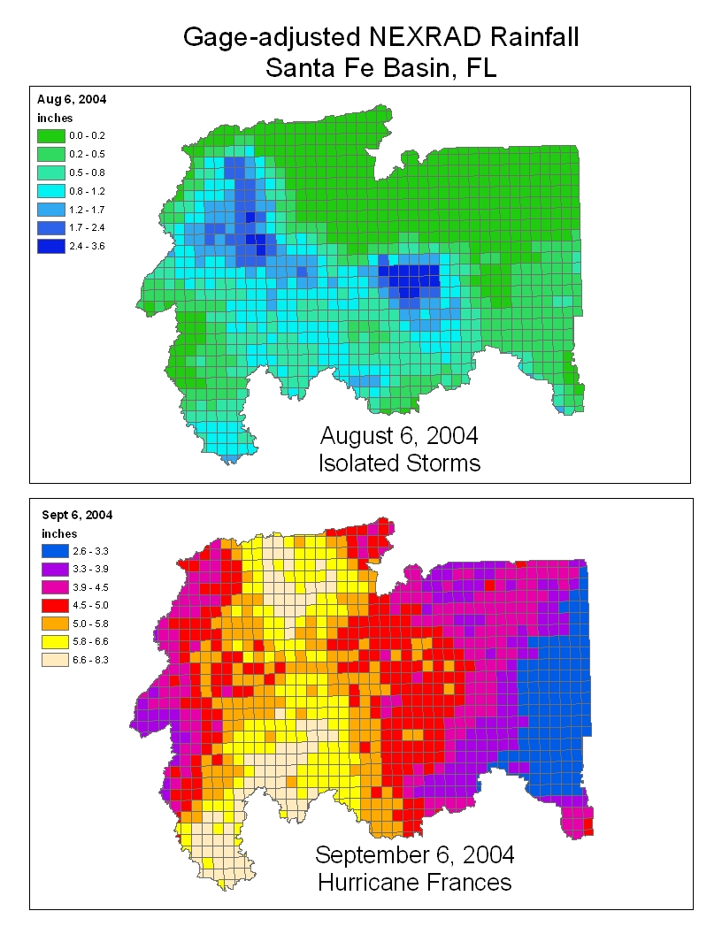
Figure 6. Gage-adjusted NexRad rainfall for August 6 and September 6, 2004 for the Santa Fe watershed, Florida.

