Station points in the Surfacewater gages sent to us from SRWMD. Those with USGSREF=0 must be monitored by SRWMD.

I distilled them down to 13 based on how much data available. I used an HIS tool to query the online NWIS database from USGS.

USGSREF | DAILY FLOW |  | Count (see.mdb I made of actual dowloaded data) since 1950
02322700 | 2/5/1957 | 9/27/2006 | 709
02322688 | 2/5/2002 | 9/30/2005 | 1334
02321500 | 10/1/1931 | 9/26/2006 | 20737
02321000 | 1/1/1950 | 9/27/2006 | 20737
02322800 | 11/1/2000 | 9/30/2005 | 20737
02322500 | 10/1/1927 | 9/7/2006 | 20737
02321975 | 10/1/1992 | 9/30/2002 | 3652
02322000 | 2/1/1931 | 9/30/1971 | 20737
02321900 | 9/30/1992 | 10/17/1996 | 1479
02320700 | 9/1/1957 | 9/30/1998 | 15030
02322685 | 2/7/2002 | 9/30/2005 | 1332
02322691 | 2/12/2002 | 9/30/2005 | 1327
02322694 | 2/12/2002 | 9/30/2005 | 1327

2 measures of flow recorded for stations; see 2 tables for discharge and elevation:
60_Params_perSite
Site_ID | count | ParameterCode | ParameterDesc | BegDate | EndDate
02320700 | 15005 | 60 | Discharge, cubic feet per second | 9/1/1957 | 9/30/1998
02321000 | 13466 | 60 | Discharge, cubic feet per second | 1/1/1950 | 9/27/2006
02321500 | 20650 | 60 | Discharge, cubic feet per second | 10/1/1931 | 9/26/2006
02321900 | 1479 | 60 | Discharge, cubic feet per second | 9/30/1992 | 10/17/1996
02321975 | 3215 | 60 | Discharge, cubic feet per second | 10/1/1992 | 9/30/2002
02322000 | 20704 | 60 | Discharge, cubic feet per second | 2/1/1931 | 9/30/1971
02322500 | 20704 | 60 | Discharge, cubic feet per second | 10/1/1927 | 9/7/2006
02322685 | 1332 | 60 | Discharge, cubic feet per second | 2/7/2002 | 9/30/2005
02322688 | 1334 | 60 | Discharge, cubic feet per second | 2/5/2002 | 9/30/2005
02322691 | 1327 | 60 | Discharge, cubic feet per second | 2/12/2002 | 9/30/2005
02322694 | 1327 | 60 | Discharge, cubic feet per second | 2/12/2002 | 9/30/2005
02322700 | 1687 | 60 | Discharge, cubic feet per second | 2/5/2002 | 9/27/2006
02322800 | 15310 | 60 | Discharge, cubic feet per second | 11/1/2000 | 9/30/2005
Discharge = Cubic Feet per second.

72020_Params_perSite
Site_ID | count | ParameterCode | ParameterDesc | BegDate | EndDate
02320700 | 12184 | 72020 | Elevation above NGVD 1929, feet | 8/7/1957 | 5/19/1994
02321000 | 12355 | 72020 | Elevation above NGVD 1929, feet | 10/1/1950 | 5/19/1994
02321500 | 19191 | 72020 | Elevation above NGVD 1929, feet | 11/18/1931 | 9/30/1993
02322000 | 2541 | 72020 | Elevation above NGVD 1929, feet | 7/1/1953 | 9/30/1971
02322500 | 2541 | 72020 | Elevation above NGVD 1929, feet | 10/1/1927 | 9/30/1992
02322700 | 1601 | 72020 | Elevation above NGVD 1929, feet | 2/19/1917 | 9/16/1974
02322800 | 353 | 72020 | Elevation above NGVD 1929, feet | 10/1/1978 | 9/30/1979

10-10-06
These are the Realtime gages and parameters measured (how can 02322000 not be real-time? same # of observations) according to website http://waterdata.usgs.gov/fl/nwis/rt
02321500 | SANTA FE RIVER AT WORTHINGTON SPRINGS, FLA.
02322500 | SANTA FE RIVER NEAR FORT WHITE, FLA.
02322700 | ICHETUCKNEE R @ HWY27 NR HILDRETH, FL
02321000 | NEW RIVER NR LAKE BUTLER FLA
02322800 | SANTA FE RIVER NR HILDRETH FLA

Realtime gages (Real-time data typically are recorded at 15-60 minute intervals, stored onsite, and then transmitted to USGS offices every 1 to 4 hours, depending on the data relay technique used. Recording and transmission times may be more frequent during critical events. Data from real-time sites are relayed to USGS offices via satellite, telephone, and/or radio and are available for viewing within minutes of arrival. All real-time data are provisional and subject to revision.):

02321500 SANTA FE RIVER AT WORTHINGTON SPRINGS, FL
 | 00060 Discharge (cubic Feet per second)
 | 00065 Gage height

LOCATION.--Lat 29°55'18", long 82°25'35", in SE1/4 sec. 32, T. 6 S., R. 19 E., Alachua
County, Hydrologic Unit 03110206, near center of span on downstream side of bridge on
State Highway 121, 0.5 mi south of Worthington Springs, 0.8 mi downstream from New River,
and 51 mi upstream from mouth.

DRAINAGE AREA.--575 mi².

PERIOD OF RECORD.--October 1931 to current year. Published as "near Worthington" prior to
October 1965. Monthly discharge only for October 1931, published in WSP 1304.

REVISED RECORDS.--WSP 2105: WDR FL-76-4: Drainage area.

GAGE.--Water-stage recorder. Datum of gage is 42.74 ft above National Geodetic Vertical
Datum of 1929 (levels by Corps of Engineers). Prior to Jan. 16, 1939, nonrecording gage
at site 0.2 mi downstream at present datum; Jan. 16, 1939 to July 23, 1953, nonrecording
gage at present site and datum.

REMARKS.--Records good. Records do not include diversions during periods of high stages from
Santa Fe Lake to Lochloosa Creek in St. Johns River Basin.

02322500 SANTA FE RIVER NEAR FORT WHITE, FL
00060 Discharge
00065 Gage height
00065 Gage height (1)

LOCATION.--Lat 29°50'55", long 82°42'55", in SE1/4 sec. 28, T. 7 S., R. 16 E., Gilchrist
County, Hydrologic Unit 03110206, on left bank 2.1 mi upstream from bridge on State
Highway 47, 5.1 mi south of Fort White, and 18 mi upstream from mouth.

DRAINAGE AREA.--1,017 mi².

PERIOD OF RECORD.--October 1927 to January 1930, June 1932 to current year.

REVISED RECORDS.--WDR FL-75-1: Drainage area.

GAGE.--Water-stage recorder. Datum of gage is 20.86 ft above National Geodetic Vertical
Datum of 1929 (levels by Corps of Engineers). Prior to June 3, 1932, nonrecording gage
at several sites within 200 ft of present site at various datums. Oct.1, 1947 to Feb. 10,
1949, auxiliary nonrecording gage and since Feb. 11, 1949, auxiliary water-stage recorder
at bridge on U.S. Highway 129, 16 mi downstream from base gage at datum 3.5 ft above
National Geodetic Vertical Datum of 1929.

REMARKS.-- Records good.

USGS 02322700 ICHETUCKNEE R @ HWY27 NR HILDRETH, FL
00065 Gage height
00060 Discharge

No similar metadata for this one.

USGS 02321000 NEW RIVER NR LAKE BUTLER FLA
00060 Discharge
00065 Gage height

No similar metadata for this one.

USGS 02322800 SANTA FE RIVER NR HILDRETH FLA
00065 Gage height
00045 Precipitation (KM note: this already coincides with a rainfall station point source=srwmdNWS)
00010 Temperature, water

No similar metadata for this one.

Has 15-minute precip. data: The 15-minute precipitation data for this station are temporary and will only be displayed for 31 days. Time series of 30-minute or cumulative daily values will NOT be available for retrieval following the 31-day display period. Although the instrumentation is calibrated at least once/year, the temporary classification means that documented routine inspections and other quality assurance measures are not performed that would make the data acceptable for archival, retrieval, or future use in general scientific or interpretive studies.

Now, for all 13:

See Excel sheet NWISSFE.xls
It has listing of SFe USGS stations, datasheet for pd of record for each one and related parameters. It has the HydroObjects macros (older version) from HIS CUAHSI group.

I made an Access DB of these 13 stations and parameter codes/dates available for each including water quality: NWIS_SFe.mdb Here are params avail for the 13 sites:

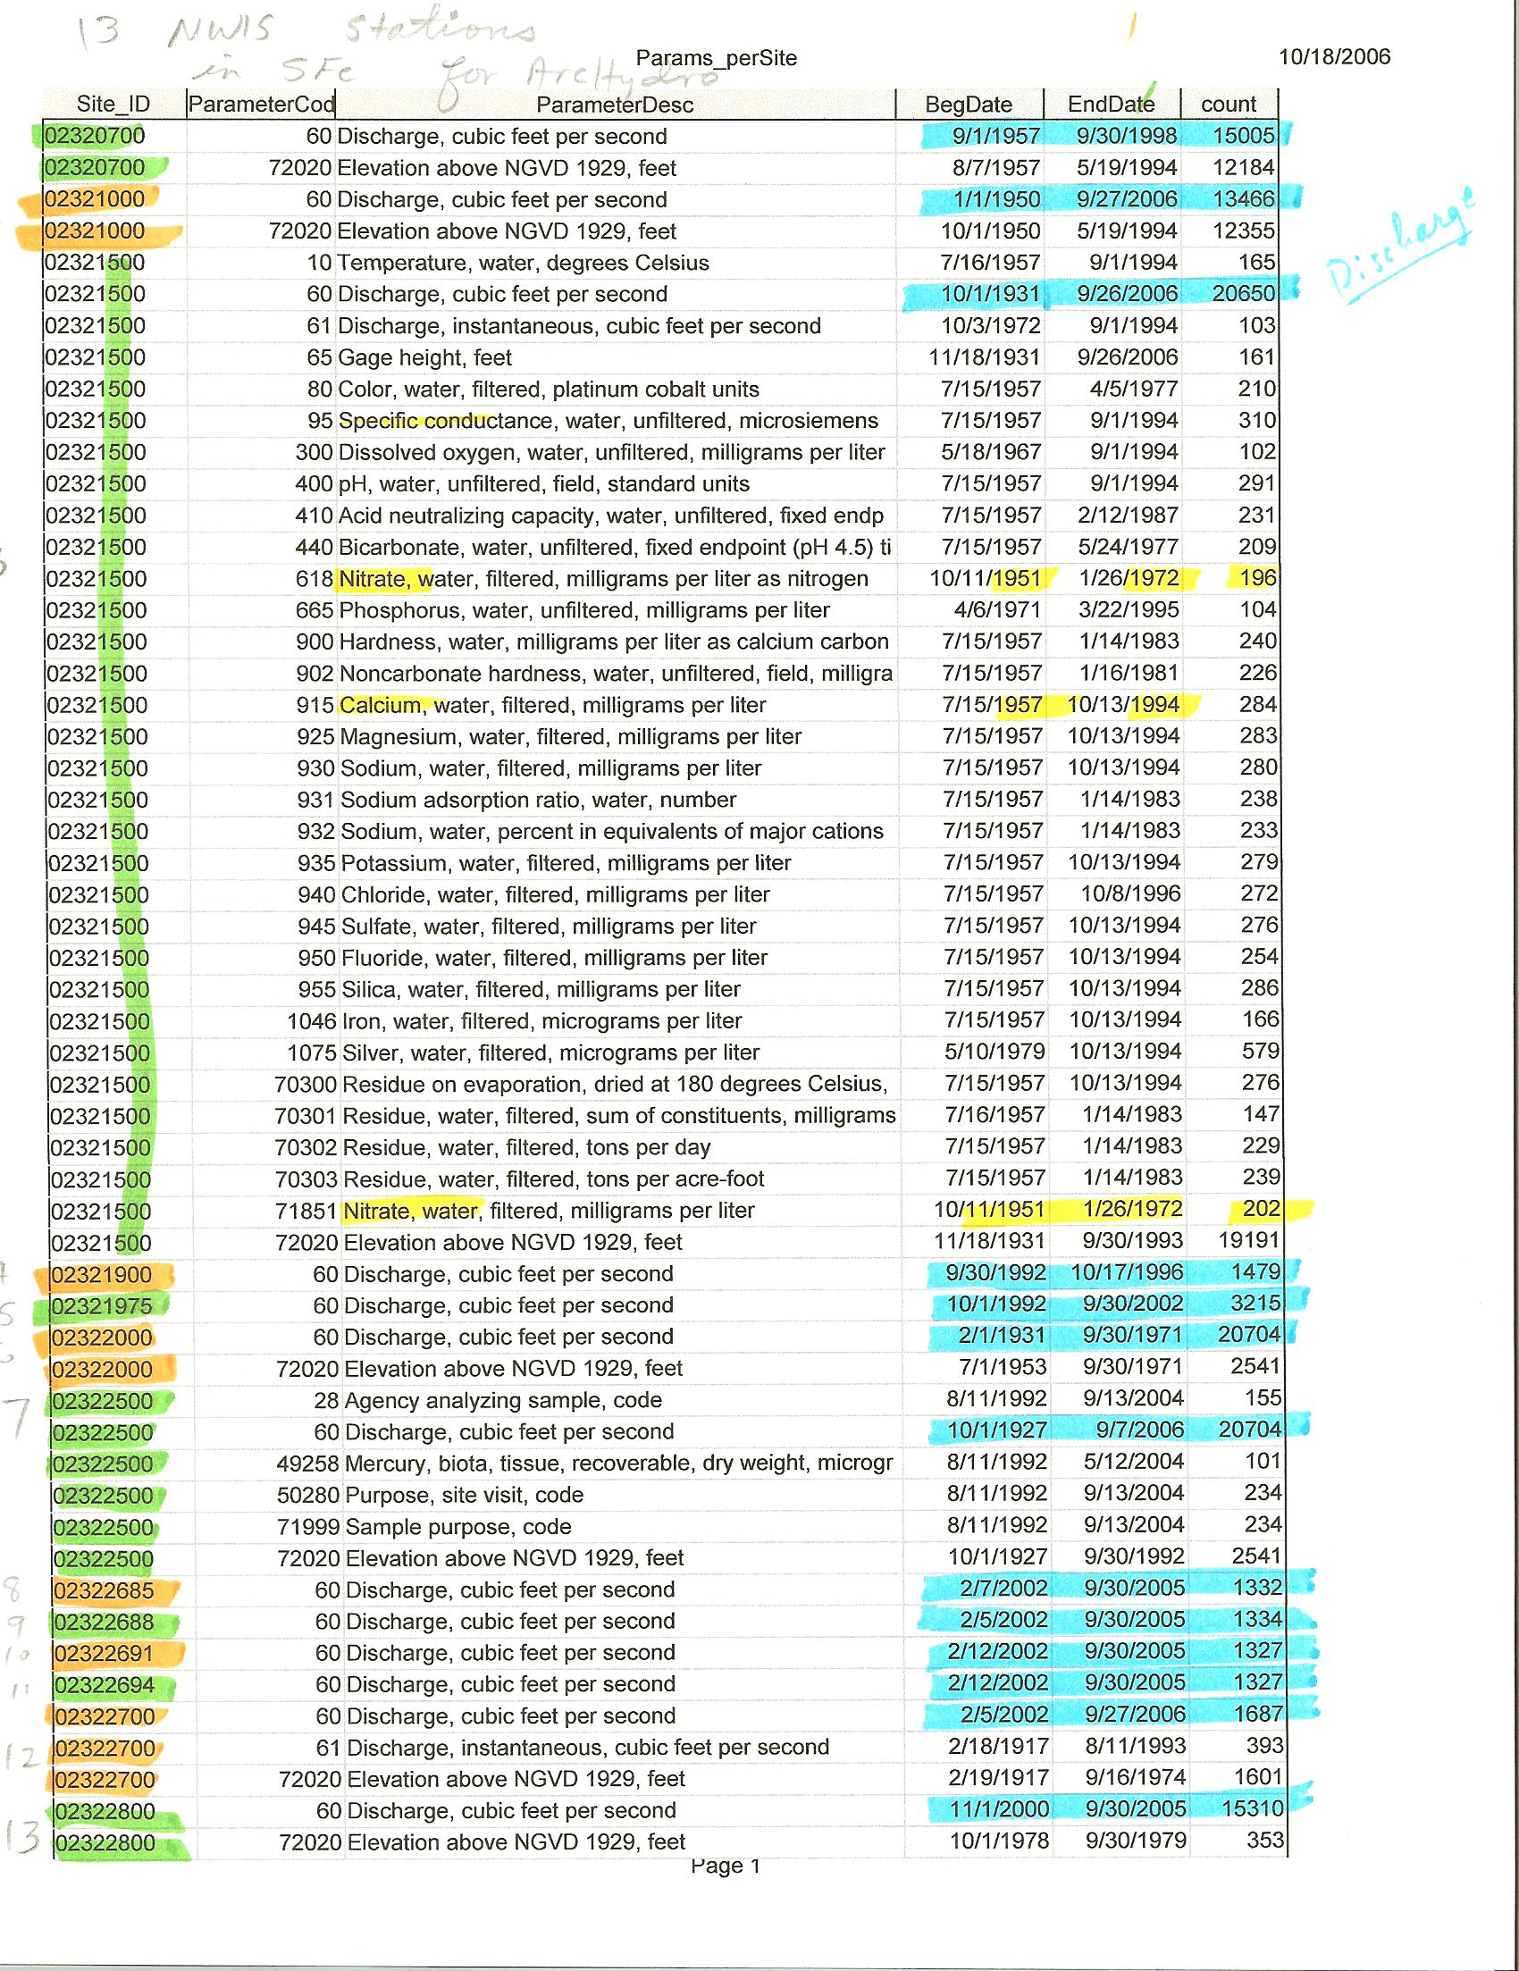
Discharge = Cubic Feet per second.



